THEORY QUESTIONS
1.
a)

Study the diagram below carefully and answer the questions that follow:
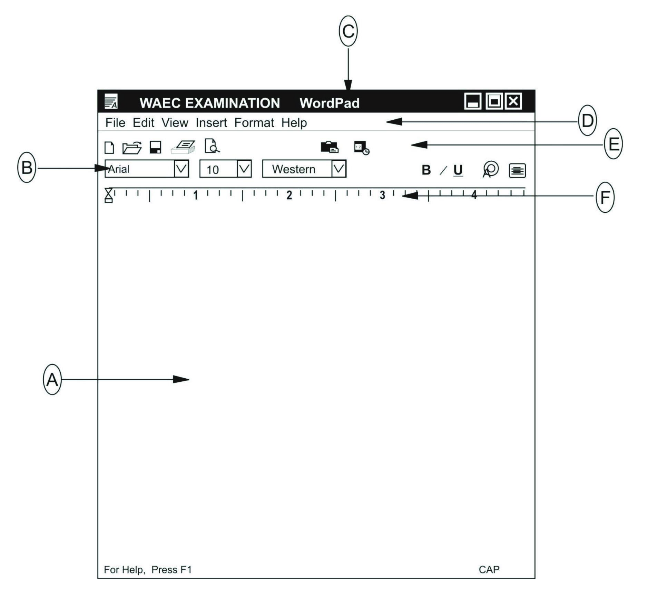
i)

What is the name of the application program used to create the above file?
ii)

Give the file name of the application program above.
iii)

Name the parts labelled A, B, C, D, E and F in the diagram.
iv)

State the functions for B and C in (a) above.
b)

List the steps (in the right order) involved in switching on a personal computer system.
c)

Identify the following ICT tools.
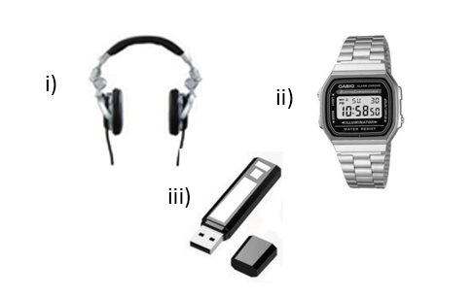
Show Solution
2.
a)

What is:
i)

Input device
ii)

Output device
b)

Classify the following into either input or output device in the table below:
i)

Microphone
ii)

Joystick
iii)

Webcam
iv)

Plotter
v)

Scanner
vi)

Mouse
Input Device | Output Device
Show Solution
3.
a)

Explain the term desktop as used in the personal computer environment.
b)

List three areas of learning where information and communication technology can be integrated.
c)

List two tools on the formatting toolbar of a word processing application.
d)

State two benefits associated with the use of information and communication tools in teaching and learning.
Show Solution
4.
a)

i)

What is internet?
ii)

List four uses of the internet.
b)

i)

What is a web browser?
ii)

Give two examples of a web browser.
Show Solution
5.
Explain the following terminologies:
a)

Cell
b)

Column
c)

Row
d)

Graph

